SOFE3950U Operating Systems Lab 4: The HOST Scheduler

The Hypothetical Operating System Testbed (HOST) is assumed to be a multitasking system in which a four-level priority process scheduler operates under the constraints of limited available resources.

Four-level Priority Process Scheduler
The scheduler operates across four priority levels:
- Real-time processes must be executed immediately according to the First Come First Served (FCFS) policy and may preempt any process with a lower priority. Such processes run to completion.
- Normal user processes are executed using a three-level feedback scheduler. The base time quantum of the scheduler is 1 second, which also serves as the time quantum for the feedback scheduler.
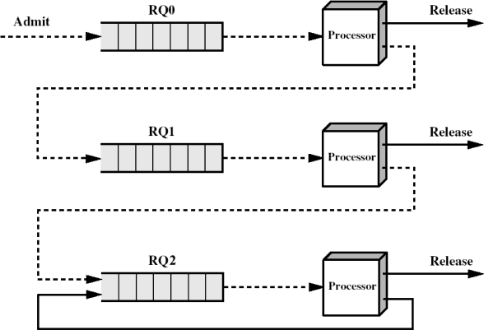
Figure 1. Three-level feedback scheduler
The scheduler maintains two submission queues — a real-time queue and a user submission queue — which receive jobs from the scheduling list. At the beginning of each timer tick (i.e., each scheduling cycle), the scheduler scans the scheduling list and transfers all jobs whose arrival_time equals the current time into the appropriate submission queue.
The scheduler then examines the submission queues. Any real-time job, once selected for execution, is scheduled according to a First-Come–First-Served (FCFS) policy and continues to run across subsequent ticks until completion. While at least one real-time job is runnable, no user job is selected for execution.
Only after the real-time queue becomes empty does the lower-priority feedback scheduler become active. User jobs initially enter the user submission queue. The scheduler scans this queue in FIFO order and admits user jobs only if the job at the head of the submission queue can be fully satisfied by both available memory and all requested I/O resources. Upon admission, the job is transferred into the ready queue corresponding to its priority level.
The feedback scheduler maintains three user priority queues. When admitted, a user job is inserted into the queue corresponding to its initial priority. After a user job executes for one time slice (1 second), if it has not completed, it is demoted according to the lab rules and reinserted into the appropriate queue before the next scheduling decision. When all user jobs eventually execute at the lowest priority level, the behavior of the scheduler becomes equivalent to that of a simple round-robin scheduler.
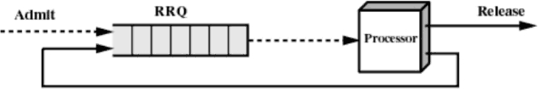
Figure 2. Round-robin scheduler
At the start of each new tick, if no real-time job is present, the scheduler selects the job at the head of the highest-priority non-empty user queue for execution. All scheduling decisions occur only at tick boundaries; a running process is not interrupted within a single tick. Process completion, priority demotion, re-queuing, and resource release are all handled uniformly during the post-run phase of the tick.
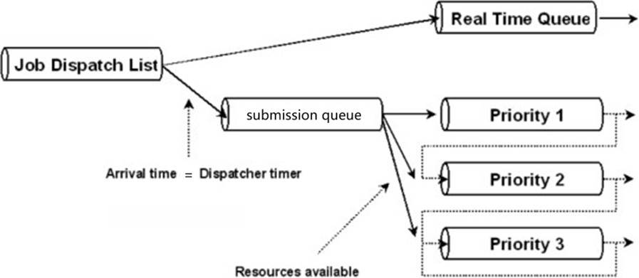
Fiture 3. Scheduler logic structure

Process Model
In this lab, a process is the basic unit managed by the scheduler.
Each process is defined by one line in the scheduling list and follows a well-defined lifecycle from arrival to termination.

Process attributes
Each process is described by the following attributes (corresponding to the process_t structure in the implementation):
- pid: Unique process identifier, assigned in input order.
  - For example, the process on the first line of the file has PID 0, and the process on the 14th line has PID 13.
- arrival_time: Time (in seconds) when the process enters the system.
- init_prio: Initial priority (0 for real-time processes; 1–3 for user processes, where smaller values indicate higher priority).
- cpu_total: Total required CPU execution time (seconds).
- mem_req: Requested contiguous memory size (MB), positive integer.
- I/O resource requests: Numbers of printers, scanners, modems, and CD drives.
- Runtime fields:
  - cpu_remain: Remaining CPU time
  - current_prio: Current priority (user processes only)
  - state: Current process state
  - mem_start: Starting address of the allocated memory block (user processes)
User processes declare all required resources at submission time and hold them exclusively for their entire lifetime.

Process states
During execution, a process may be in one of the following states:
- NEW: Read from the scheduling list but not yet arrived.
- SUBMITTED: Arrived in the system and placed into the real-time queue or submission queue.
- READY: Admitted and waiting in a user queue.
- RUNNING: Executing on the CPU for the current tick.
- TERMINATED: Completed execution; all resources have been released.

Real-time vs. user processes
Real-Time Processes (init_prio = 0)
- Scheduled using FCFS.
- Execute continuously until completion.
- Do not request I/O resources.
- Always occupy the reserved 64MB real-time memory region.
User Processes (init_prio = 1, 2, 3)
- Managed by a multi-level feedback scheduler.
- Require both memory and I/O resources at admission.
- Use memory allocated from the user region [64, 1023].

Dispatch List
The dispatch list is a text file that contains the list of processes the dispatcher will handle. This file provides the process information to be read as input by the dispatcher.
Each line in the list describes one process, formatted as a whitespace-delimited sequence containing the following fields:
<arrival time> <priority> <CPU time> <Mbytes> <printers> <scanners> <modems> <CDs>
Thus,
12 0 1 64 0 0 0 0
12 1 2 128 1 0 0 1
13 3 6 128 1 0 1 2
Indicates:
The first process arrives at time 12, has priority 0 (real-time), and requires 1 second of CPU time and 64 MB of memory, with no I/O resources requested.
The second process arrives at time 12, has priority 1 (high-priority user job), and requires 2 seconds of CPU time, 128 MB of memory, 1 printer, and 1 CD drive.
The third process arrives at time 13, has priority 3 (lowest-priority user job), and requires 6 seconds of CPU time, 128 MB of memory, 1 printer, 1 modem, and 2 CD drives.
The dispatch list file can be of any length (up to 10, 20, 30, …, 128 processes). It ends with a newline followed by an end-of-file marker. Note that dispatch lists will form the basis of the tests applied to your submitted scheduler during marking, and the scheduler is expected to behave exactly as required.
A test dispatch list and its expected output are provided in the starter code package. Clearly, your submitted dispatcher will also be tested with more complex combinations.

Available Resource
HOST provides the following resources:
- 2 printers
- 1 scanner
- 1 modem
- 2 CD drives
- 1024 MB of memory available for processes
Low-priority processes may use any or all these resources. When a process is submitted, it declares to the HOST scheduler which resources it will use. The scheduler ensures that each requested resource remains exclusively allocated to that process throughout its entire lifetime (from the initial transfer from the submission queue to the priority 1–3 queues until process completion, including any intervening idle time quanta).
Real-time processes do not require any I/O resources (printer/scanner/modem/CD), but they do require memory allocation—each real-time job will always request 64 MB of memory.
A process’s resource requests will not exceed the system totals; for example, there will be no case where a process requests three printers.

Memory Allocation
Each process must be allocated a contiguous block of memory, and this block must remain exclusively assigned to the process for its entire lifetime.
Sufficient contiguous spare memory must be reserved to ensure that real-time processes are not blocked due to insufficient memory. A running real-time job uses 64 MB of memory, leaving the remaining 960 MB to be shared among “active” user jobs. You MUST reserve the lowest-address 64 MB region for real-time processes; therefore, user processes may ONLY be allocated memory within the range [64, 1023]. (All process memory sizes are integers.)
For fair and deterministic grading, contiguous memory allocation in this lab MUST use the First Fit strategy. Any implementation that does not strictly follow the rules below will be considered non-compliant with the First Fit requirement. Given the same input, a First Fit implementation that strictly follows these rules will produce identical memory allocation results, ensuring deterministic auto-grading.
FIRST FIT:
- Scanning Rule:
  - User-process memory allocation must NOT occupy or cross the real-time memory region.
  - When allocating memory, you must scan free blocks from the lowest address to higher addresses.
  - Allocate the first free block encountered whose size is larger than the process’s requested size.
  - You must NOT continue scanning from the previous allocation position (that behavior is Next Fit).
    - Example: if the free blocks are (90–100), (200–500), (600–800), then each allocation must start scanning from address 90 and proceed until the first sufficiently large free block is found.
- Splitting Rule (when the selected free block is larger than the requested size):
  - Allocation MUST be taken from the low-address end.
  - The remaining portion becomes a new free block whose starting address is: original start address + requested size.
    - Example: if the free block is 75–200 and the new process requests 50 MB, you must allocate 75–124 to the process, and the new free block must start at 75 + 50 = 125.
- Coalescing Rule (when a process terminates and releases memory):
  - You must check and merge adjacent free blocks.
    - Adjacent to the previous free block → merge.
    - Adjacent to the next free block → merge.
    - If adjacent to both previous and next free blocks, all must be merged into one contiguous free block.
  - The real-time memory region must NOT be merged with the user memory region.
- Free-Block Maintenance Requirements:
  - All free memory blocks must be maintained in strictly increasing order of starting address.
  - At any time:
    - Free blocks must not overlap.
    - Free blocks must not remain adjacent without being merged.

Scheduler Requirements
- If multiple processes arrive at the same time, they are executed in top-to-bottom order according to the file line order.
- Real-time processes must run immediately upon arrival. All real-time processes submitted for execution from the dispatch list must be scheduled according to the First Come First Served (FCFS) policy.
- After a process has been executed for one second, the dispatcher must print the process parameters, including: <current time> <process PID>, <current priority>, <remaining CPU time>, <memory start address>, <requested Mbytes>, <printers>, <scanners>, <modems>, <CDs>.
- If a user process has not completed after running for one second at its current priority level, the dispatcher must lower its priority if possible and re-queue it into the corresponding priority queue as shown in Figures 1 and 3 above.
- If a user process is suspended by a higher-priority user process, its priority should be lowered if possible and it should be re-queued into the corresponding priority queue as shown in Figures 1 and 3 above. (In this lab, if your implementation is correct, this situation will not occur, because preemption is checked only at tick boundaries (the DISPATCH stage).)
- If the processes provided in the dispatch list are all at the lowest priority level, the dispatcher will emulate a simple Round Robin scheduler.
- If there is no pending real-time process in the dispatch list, the highest priority pending process should be started or resumed.
- When a process terminates, its resources are released for use by other processes.
- Spare memory must be reserved to ensure that real-time processes can execute without hindrance. Each real-time process requires 64 MB of memory to run, leaving 960 MB available to any “active” user process.
- When a process requests a resource, the dispatcher ensures that the resource is exclusively allocated to that process for its entire lifetime.
- Real-time processes do not require any I/O resources (printer/scanner/modem/CD).

Tick Processing Order:
Within each tick, the system must execute the following phases in order:
ARRIVAL → USER ADMIT → DISPATCH → RUN → POST-RUN
Phase Requirements:
ARRIVAL
- All processes with arrival_time == current_time must be handled together at the beginning of the tick.
- User processes enter the submission queue in the same order as in the input file, while real-time processes enter the real-time queue.
- This phase may only handle arrivals; no resource allocation or CPU execution is allowed.
USER ADMIT
- Scan the user submission queue using a FIFO policy. Resources must be allocated strictly in arrival order, and the admitted process must be inserted into the queue corresponding to its init_prio.
- Process priority must not affect admission or resource allocation. Always allocate resources for the process at the head of the submission queue first; priority is used only in the DISPATCH phase.
- A process may be admitted only when both memory and all requested I/O resources are simultaneously available.
- If the process at the head of the submission queue cannot be admitted, the admission phase for this tick ends immediately, and no subsequent processes may be admitted.
- Resource allocation must be completed at the moment of admission.
- This phase must be executed every tick to admit user processes, regardless of which process will run during the tick.
DISPATCH
- If the real-time queue is non-empty, select a real-time process with highest priority over any user process.
- Otherwise, select the head process from the user queues, scanning from highest to lowest priority.
- This phase only performs selection and does not consume CPU time.
RUN
- The selected process “executes” for exactly 1 second.
- The process’s cpu_rem is decremented by 1.
PRINT
- Print the parameters of the currently running process in the following format:
    - [t = <current_time>]> RUN <process PID>, <current priority>, <remaining CPU time>, <memory start address>, <requested Mbytes>, <printers>, <scanners>, <modems>, <CDs>
    - Example: [t=12] RUN PID=3 PR=2 CPU=5 MEM_ST=64 MEM=200 P=1 S=0 M=0 C=1
- If no process is running, print IDLE.
    - Example: [t=13] IDLE
- This part is already implemented in the starter code. It is strongly recommended to use the provided print_log() function to avoid formatting errors.
POST-RUN
- If the process completes (cpu_rem == 0), it must be terminated and all resources it holds must be released.
- If the process does not complete, suspend it, downgrade its priority if possible, and re-queue it into the appropriate ready queue according to the lab rules.
- Real-time processes are never downgraded and must continue running until that real-time process finishes before any other process may run.
- All resource releases may occur only in this phase.

Deliverables
- Please answer the following questions in a document named “report.pdf”, it is expected to contain in-depth discussions, descriptions, and arguments:
  - Describe and discuss how you implemented the First Fit memory allocation algorithm. If your implementation is incorrect, this will be used as a basis for grading.
  - Explain why a multilevel scheduling scheme is used, and compare it with schemes adopted by “real” operating systems. Outline the shortcomings of such a scheme and propose possible improvements. Your discussion must include the memory and resource allocation schemes.
  - The design document must not include any source code.
- Implement the dispatcher in C.
  - The scheduler should follow the requirements above to ensure the following operations:
    - FCFS operation for the real-time high-priority scheduler.
    - Operation of the user feedback scheduler.
    - Operation of the user feedback scheduler in Round Robin mode.
    - Mixed scheduler operation.
    - Resource allocation.
    - Memory management.
    - Combination of all requirements.
  - The source code must be commented and appropriately structured so that peers can understand and easily maintain it. If your code fails to compile or fails the tests, this will be used as a basis for grading.

Submission Requirements
The submission must be a .tar.gz file containing the source code files and a “groupX_report.pdf” document.
  - Do NOT include any executable files. The marking system will automatically rebuild the program from the provided source code. If the submitted code cannot be compiled, it cannot be marked.
  - Please include the full names of all group members in both the source code files and the report.
  - Submission requirements: your submission file must be named groupX_scheduler.tar.gz (all lower case) and must not contain any subfolders. Your archive must include a correct makefile so that it can be compiled using the $make command and will generate an executable named groupX_scheduler.
  - Before submission, please verify that X has been replaced with your group number in all relevant items, including the .tar.gz file, the .c source files, and the compiled executable! An example structure is as follows:
group12_scheduler.tar.gz
├── group12_report.pdf
├── group12_scheduler.c (skeleton provided)
├── queue.c (provided)
├── queue.h (provided)
├── Makefile (provided, but need to be revised)
└── other files…

Marking Criteria
This project is marked out of 100.
The submitted documentation is worth 30 marks and will be assessed based on depth of discussion, readability, maintainability, completeness, and demonstration of an understanding of the problem and the proposed solution:
- Description, discussion, and justification of your memory allocation implementation — 15 marks
- Discussion of the scheduling scheme (including memory and resource allocation), analysis of shortcomings, and suggestions for improvements — 15 marks
The remaining 70 marks will be based on the dispatcher’s runtime behavior, functionality, and performance on different dispatch lists:
- FCFS operation in the real-time high-priority scheduler — 10 marks
- Operation of the user feedback scheduler — 10 marks
- Operation of the user feedback scheduler in Round Robin mode — 10 marks
- Mixed scheduler operation — 10 marks
- Resource allocation — 5 marks
- Memory management — 5 marks
- Combination of all requirements — 10 marks
Partial marks will be awarded for incomplete projects or programs that implement only a subset of the requirements. If only part of the project has been attempted, a statement to that effect should be included in the submission.

